7.1.13 Display of core values in the institution and on its website (Yes) (1)

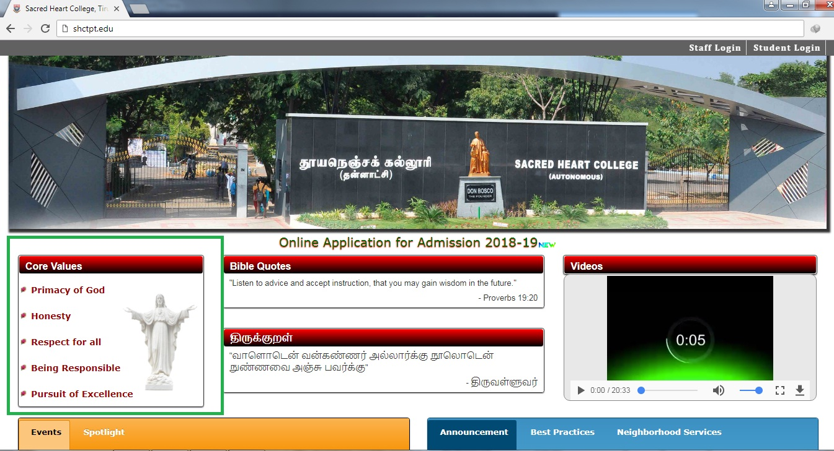
Core Values in the College Website

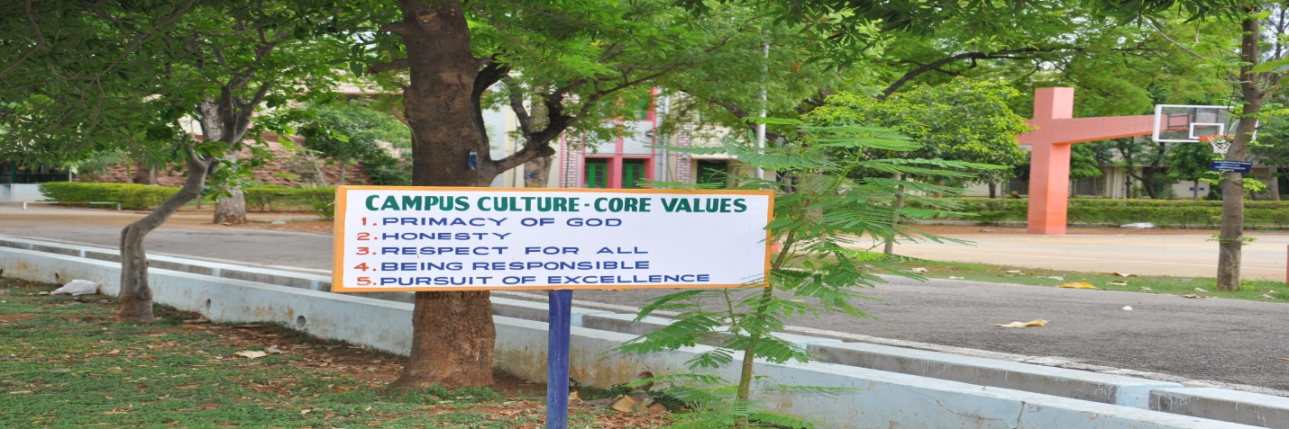
Core Values near Basket Ball Ground

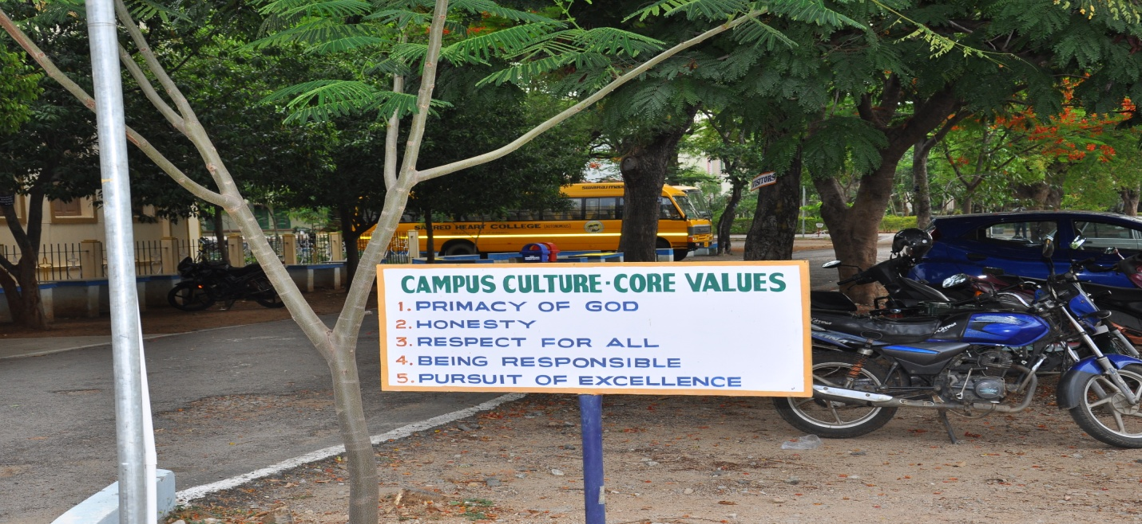
Core Values near Shrine

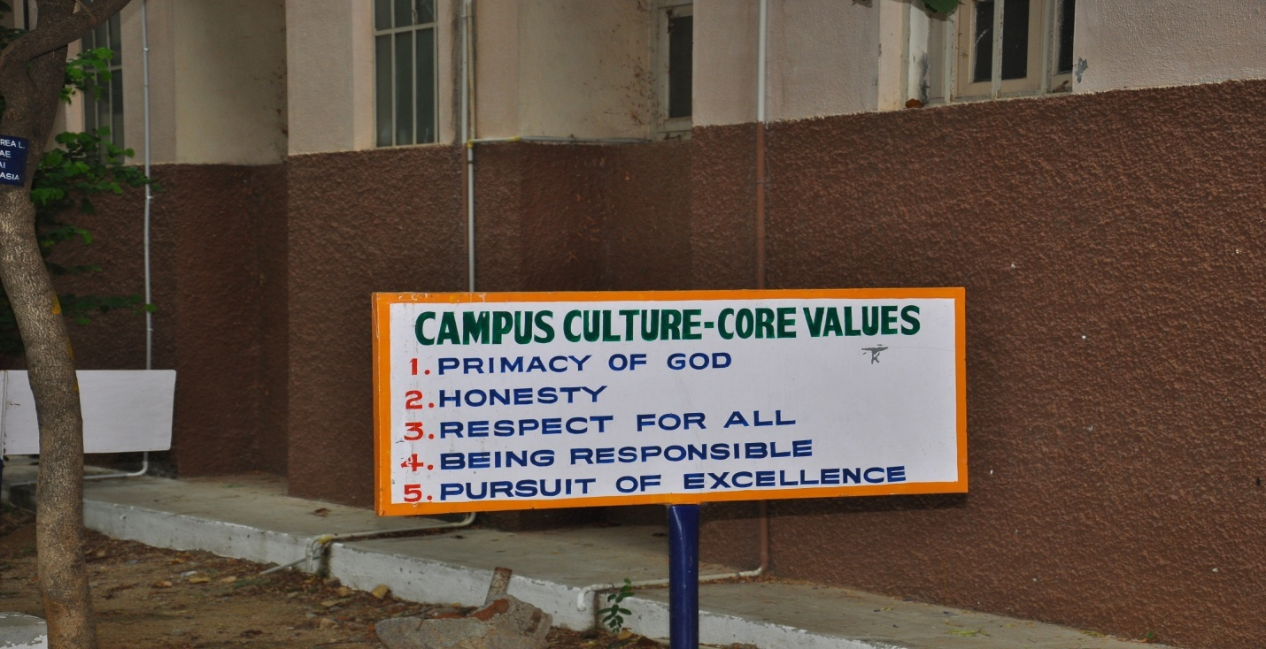
Core Values at Golden Jubilee Building

