2.3.2.Report on Learning Management System - MOODLE
Teaching and Learning Process is undergoing significant changes with the use of technology and Internet. The advent of Learning Management System such as MOODLE (Modular Object Oriented Dynamic Learning Environment) had changed the process of knowledge dissemination. As the e-Learning platform is an innovative shift in the field of learning many universities and Colleges have started offering online courses. Present pandemic [Covid – 19] situation forced the educational institution to adopt technology in the process of teaching and learning.
Sacred Heart College (Autonomous) has taken initiative to promote online learning among students and faculty members. Infrastructure has been set to facilitate the faculty members and students to get used with technology enabled teaching and learning.
Separate domain for each department has been created and each faculty members have assigned with credentials to use the learning platform. The details of the domains are as follows.
S.No | Department | URL
1 | Tamil | http://leapshc.org/tamil/
2 | English | http://leapshc.org/english/
3 | Maths | http://leapshc.org/maths/
4 | Physics | http://leapshc.org/physics/
5 | Chemistry | http://leapshc.org/chemistry/
6 | Computer Science | http://leapshc.org/elearnug/
7 | Economics | http://leapshc.org/economics/
8 | Commerce | http://leapshc.org/commerce/
9 | Commerce C.A | http://leapshc.org/commerceca/
10 | BBA | http://leapshc.org/bba/
11 | Bio-Chemistry & Micro-Biology | http://leapshc.org/biochemistry/
12 | MSW | http://leapshc.org/msw/
13 | MBA | http://leapshc.org/mba/
14 | BCA | http://leapshc.org/bca/
15 | Counseling and Psychology | http://leapshc.org/psychology/
16 | MCA | http://leapshc.org/mca/

Sacred Heart College also able to get Microsoft Teams educational institution license for teaching and learning.
To make the faculty members to be comfortable with MOODLE and Microsoft Teams platform, they are given hands on training.
An admin in each department takes the responsibility of maintaining the site. They create courses and assign roles to the students and the course teachers. Special training provided to the admin on administering the MOODLE site. The activities carried out by the admin and the faculty members.
- The admin arranges hands on training to the students through association activities.
- Staff members are uploading their course materials and started assessment like assignment, quiz etc.
- The online exams were conducted through MOODLE platform.
Faculty members and students are very much impressed by the features built in MOODLE and Microsoft Teams platforms.
MOODLE Platform

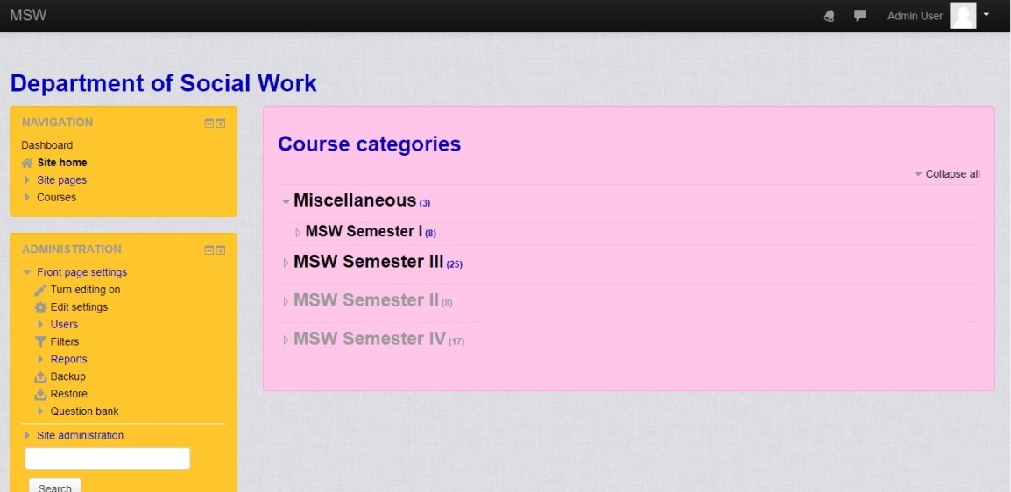

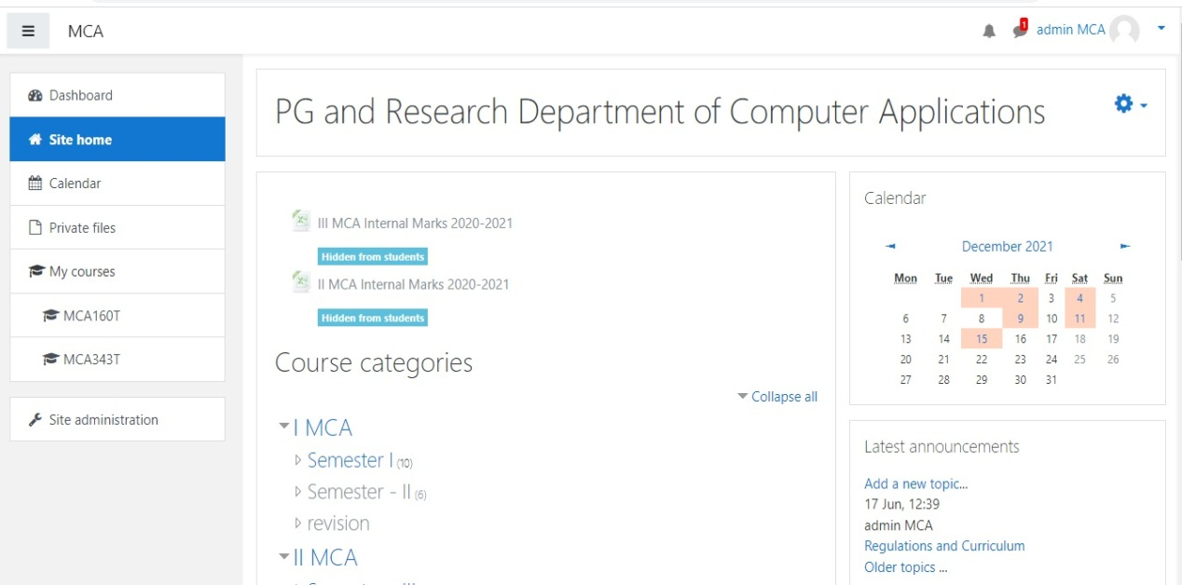

MS Teams
